**Linear Search:**

#include <stdio.h>

int main()

{

int find, n, i;

printf("Enter the size of the array:");

scanf("%d",&n);

int arr[n];

printf("Enter the elements for array:");

for(i=0; i<n; i++){

scanf("%d",&arr[i]);

}

printf("Enter the element that you want to find:\n");

scanf("%d",&find);

for(i=0; i<n; i++){

if (arr[i] == find){

printf("Element you are finding is present at %d", i);

break;

}

if (i == n - 1) {

printf("Element you are finding is not in the array:");

}

}

return 0;

}

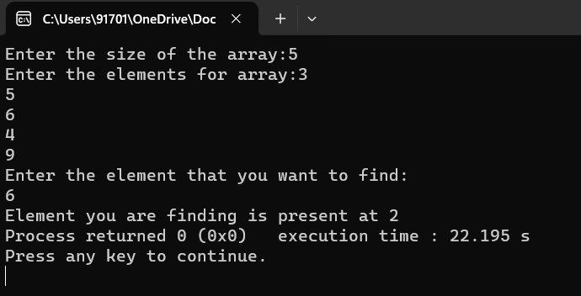

**Binary search:**

#include <stdio.h>

int binarySearch(int arr[], int l, int r, int x) {

while (l <= r) {

int m = l + (r - l) / 2;

if (arr[m] == x)

return m;

if (arr[m] < x)

l = m + 1;

else

r = m - 1;

}

return -1;

}

int main() {

int n, i, search, array[100];

printf("Enter number of elements: ");

scanf("%d", &n);

printf("Enter %d integers: ", n);

for (i = 0; i < n; i++)

scanf("%d", &array[i]);

printf("Enter the value to find: ");

scanf("%d", &search);

int result = binarySearch(array, 0, n - 1, search);

if (result == -1)

printf("Not found! %d is not present in the list.\n", search);

else

printf("The element is present at index %d.\n", result + 1);

return 0;

}

